Assignment 2

OS Lab 110698

11762 Muhammad Kashif

Task 1 (Group Chatting)

Client Code

#include<stdio.h>

#include<unistd.h>

#include<string.h>

#include<fcntl.h>

#include<sys/stat.h>

#include<sys/types.h>

#define FIFO_FILE "MYFIFO"

int main(){

int fd2;

char* myfifo = "/home/kali/Documents/lab_10/myfifo";

mkfifo(myfifo,0666);

char readbuf1[80],readbuf2[80],readbuf3[80];

while(1){

printf("You can type your message\n");

fd2=open(myfifo,O_CREAT|O_WRONLY);

fgets(readbuf1,80,stdin);

write(fd2,readbuf1,strlen(readbuf1)+1);

close(fd2);

fd2=open(myfifo,O_RDONLY);

read(fd2,readbuf2,sizeof(readbuf2));

printf("Read Kashif Message %s\n",readbuf2);

read(fd2,readbuf3,sizeof(readbuf3));

printf("Read Server Message %s\n",readbuf3);

close(fd2);}

return 0;}

Client Output

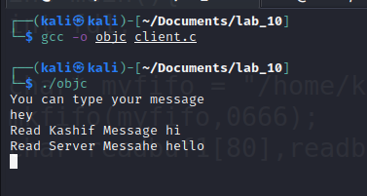

Server Code

#include<stdio.h>

#include<unistd.h>

#include<string.h>

#include<fcntl.h>

#include<sys/stat.h>

#include<sys/types.h>

#define FIFO_FILE "MYFIFO"

int main(){

int fd;

char* myfifo = "/home/kali/Documents/lab_10/myfifo";

mkfifo(myfifo,0666);

char readbuf1[80],readbuf2[80],readbuf3[80];

while(1){

printf("You can type your message\n");

fd=open(myfifo,O_CREAT|O_WRONLY);

fgets(readbuf3,80,stdin);

write(fd,readbuf3,strlen(readbuf3)+1);

close(fd);

fd=open(myfifo,O_RDONLY);

read(fd,readbuf1,sizeof(readbuf1));

printf("Read Client Message %s\n",readbuf1);

read(fd,readbuf2,sizeof(readbuf2));

printf("Read Kashif Message %s\n",readbuf2);

close(fd);}

return 0;}

Server Output

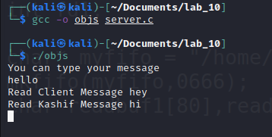

Kashif Code

#include<stdio.h>

#include<unistd.h>

#include<string.h>

#include<fcntl.h>

#include<sys/stat.h>

#include<sys/types.h>

#define FIFO_FILE "MYFIFO"

int main(){

int fd1;

char* myfifo = "/home/kali/Documents/lab_10/myfifo";

mkfifo(myfifo,0666);

char readbuf1[80],readbuf2[80],readbuf3[80];

while(1){

printf("You can type your message\n");

fd1=open(myfifo,O_CREAT|O_WRONLY);

fgets(readbuf2,80,stdin);

write(fd1,readbuf2,strlen(readbuf2)+1);

close(fd1);

fd1=open(myfifo,O_RDONLY);

read(fd1,readbuf1,sizeof(readbuf1));

printf("Read Client Message %s\n",readbuf1);

read(fd1,readbuf3,sizeof(readbuf3));

printf("Read Server Message %s\n",readbuf3);

close(fd1);}

return 0;}

Kashif Output

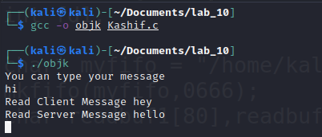

Task 2 (ATM Machine)

#include <stdio.h>

#include <pthread.h>

#include <unistd.h>

#define NO_THREAD 15

#define CASH_LIMIT 10000

#define BALANCE 150000

int cash_balance = BALANCE;

pthread_mutex_t balance_mutex;

pthread_cond_t client_ready;

void *atm_thread(void *arg) {

int id = *((int *) arg);

int password;

int choice;

int amount;

pthread_mutex_lock(&balance_mutex);

pthread_cond_wait(&client_ready, &balance_mutex);

pthread_mutex_unlock(&balance_mutex);

printf("Thread No %d: Please Enter your password: ", (id+1));

scanf("%d", &password);

printf("Thread No %d: Enter your choice (1 - Check Balance, 2 - Withdraw): ", (id+1));

scanf("%d", &choice);

pthread_mutex_lock(&balance_mutex);

if (choice == 1) {

printf("Thread No %d: Your balance is %d\n", (id+1), cash_balance);

} else if (choice == 2) {

printf("Thread No %d: Please Enter the amount to withdraw: ", (id+1));

scanf("%d", &amount);

if (amount > cash_balance) {

printf("Thread No %d: Insufficient balance\n", (id+1));

} else if (cash_balance - amount < CASH_LIMIT) {

printf("Thread No %d: ATM is out of cash\n", (id+1));

} else {

cash_balance -= amount;

printf("Thread No %d: Successfully withdrew %d. Your balance is %d\n", (id+1), amount, cash_balance);}}

pthread_mutex_unlock(&balance_mutex);

return NULL;}

int main(void) {

pthread_t threads[NO_THREAD];

pthread_mutex_init(&balance_mutex, NULL);

pthread_cond_init(&client_ready, NULL);

int i;

int thread_ids[NO_THREAD];

for (i = 0; i < NO_THREAD; i++) {

thread_ids[i] = i;

pthread_create(&threads[i], NULL, atm_thread, &thread_ids[i]);}

for (i = 0; i < NO_THREAD; i++) {

pthread_cond_signal(&client_ready);

pthread_join(threads[i], NULL);}

pthread_cond_destroy(&client_ready);

pthread_mutex_destroy(&balance_mutex);

return 0;}

Output

